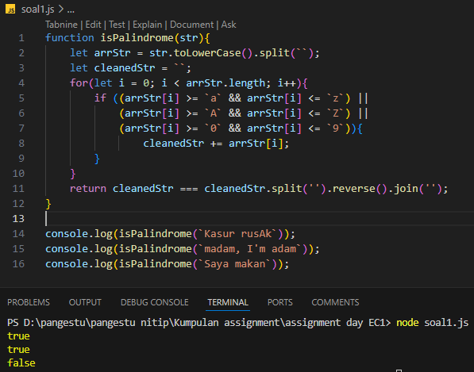
- Palindrome Function
function isPalindrome(str){
let arrStr = str.toLowerCase().split(``);
let cleanedStr = ``;
for(let i = 0; i < arrStr.length; i++){
if ((arrStr[i] >= `a` && arrStr[i] <= `z`) ||
(arrStr[i] >= `A` && arrStr[i] <= `Z`) ||
(arrStr[i] >= `0` && arrStr[i] <= `9`)){
cleanedStr += arrStr[i];
}
}
return cleanedStr === cleanedStr.split('').reverse().join('');
}
console.log(isPalindrome(`Kasur rusAk`));
console.log(isPalindrome(`madam, I'm adam`));
console.log(isPalindrome(`Saya makan`));
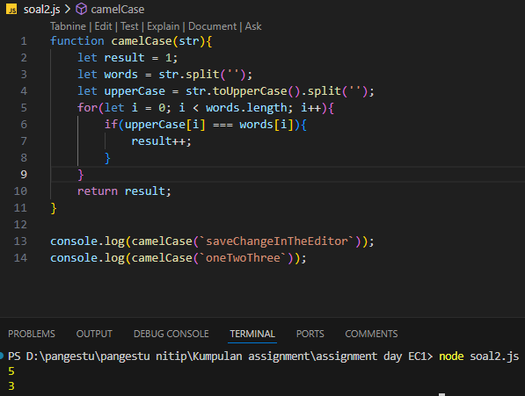

- Checking camelCase Function
function camelCase(str){
let result = 1;
let words = str.split('');
let upperCase = str.toUpperCase().split('');
for(let i = 0; i < words.length; i++){
if(upperCase[i] === words[i]){
result++;
}
}
return result;
}

console.log(camelCase(`saveChangeInTheEditor`));
console.log(camelCase(`oneTwoThree`));

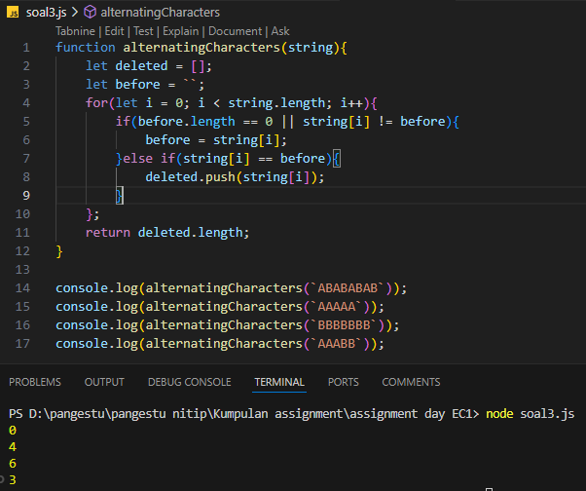
- Count the Deletion
function alternatingCharacters(string){
let deleted = [];
let before = ``;
for(let i = 0; i < string.length; i++){
if(before.length == 0 || string[i] != before){
before = string[i];
}else if(string[i] == before){
deleted.push(string[i]);
}
};
return deleted.length;
}

console.log(alternatingCharacters(`ABABABAB`));
console.log(alternatingCharacters(`AAAAA`));
console.log(alternatingCharacters(`BBBBBBB`));
console.log(alternatingCharacters(`AAABB`));

